**Client Server Architecture**

**Client Server Architecture:** The Client-server model is a distributed application structure that partitions task or workload between the providers of a resource or service, called servers, and service requesters called clients.

In the client-server architecture, when the client computer sends a request for data to the server through the internet, the server accepts the requested process and delivers the data packets requested back to the client.

**Working of Web Servers:** There are following Steps through which a Web Severes connects with the client.

* Whenever a User enters the **URL** (Uniform Resource Locator) of the website or file. Browser will request the **DNS** (Domain Name System) Server.
* Now the DNS server will look for the address for the **WEB** server.
* DNS server responds with the **IP** address of the **web** server.
* Browser sends over an **HTTP/HTTPS** request to **WEB Server’s IP** which was provided by **DNS server.**
* Now the server will send the necessary files of the website.
* Finally, Browser will render the files and website will display the following file to the client.

**Flow Chart of Client Server Architecture**

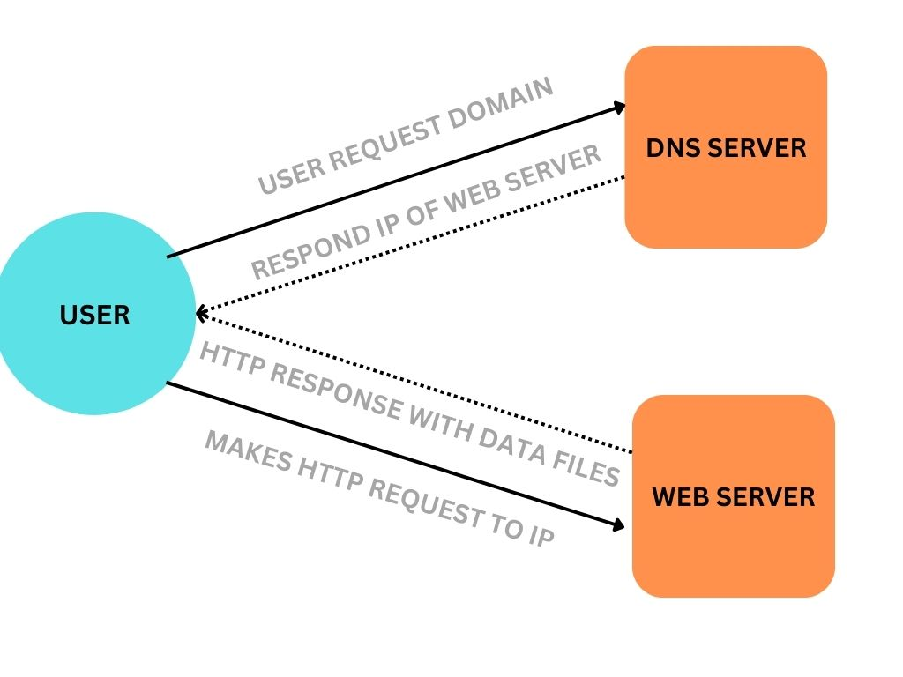

[**https://www.canva.com/design/DAFbehd21mY/4iaRUgRVAm0RsS3Wpqwpjg/view?utm_content=DAFbehd21mY&utm_campaign=designshare&utm_medium=link&utm_source=publishsharelink**](https://www.canva.com/design/DAFbehd21mY/4iaRUgRVAm0RsS3Wpqwpjg/view?utm_content=DAFbehd21mY&utm_campaign=designshare&utm_medium=link&utm_source=publishsharelink)

**WEB APPLICATION ARCHITECTURE**

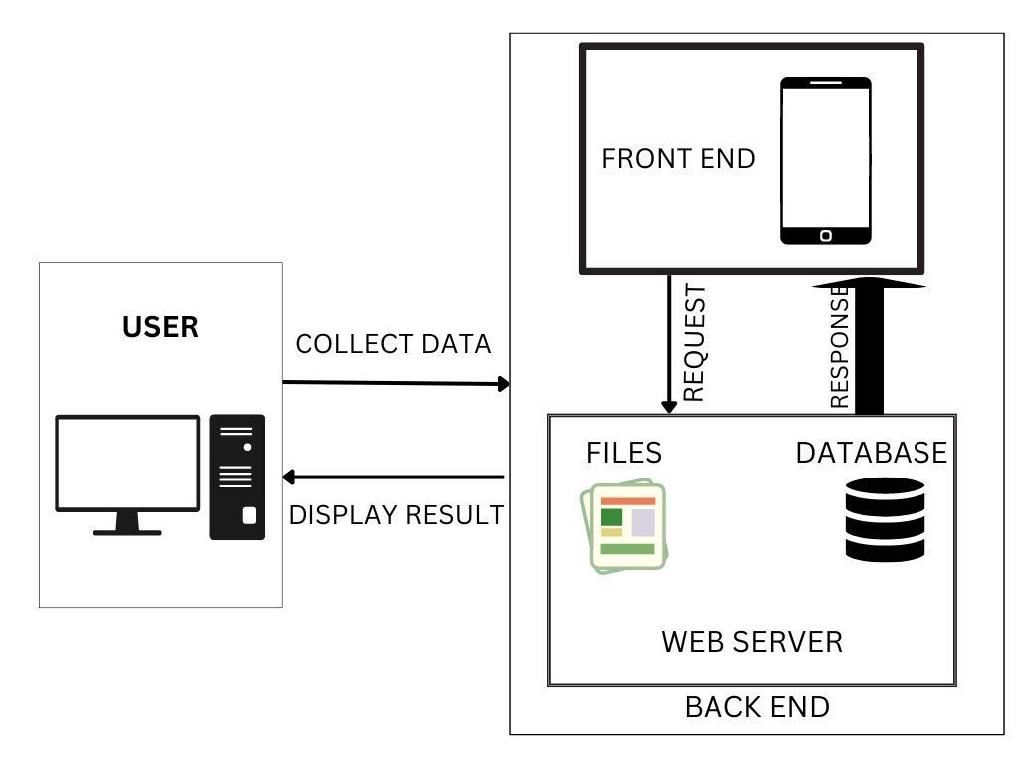

<https://www.canva.com/design/DAFbez3uSh4/IQL_I78AtQPJeQAal3kfuw/view?utm_content=DAFbez3uSh4&utm_campaign=designshare&utm_medium=link&utm_source=publishsharelink>